- Go to the Biochemistry at Virginia Tech Advising page at www.biochem.vt.edu and click on the “Schedule Advising,” icon.

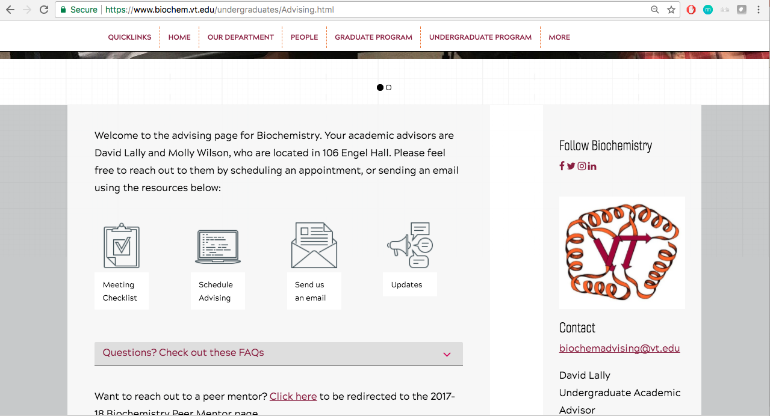

- The link in the icon will take you to the EAB Student Home page where you will then click on “Get Advising.”

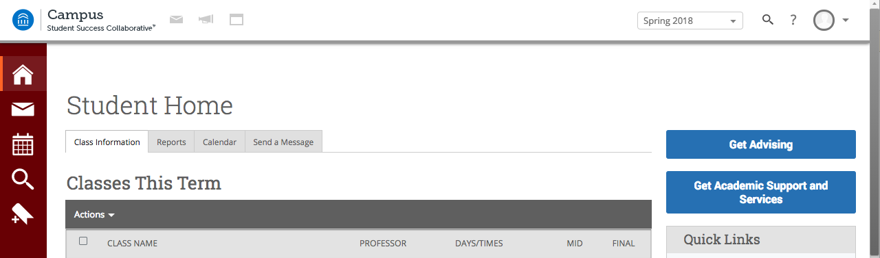

- Click on the Agriculture and Life Sciences Advising tab (BCHM) or Science Advising tab (BIOC).

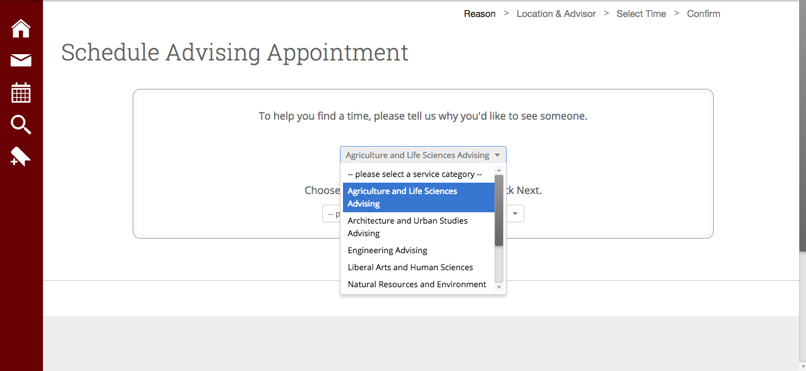
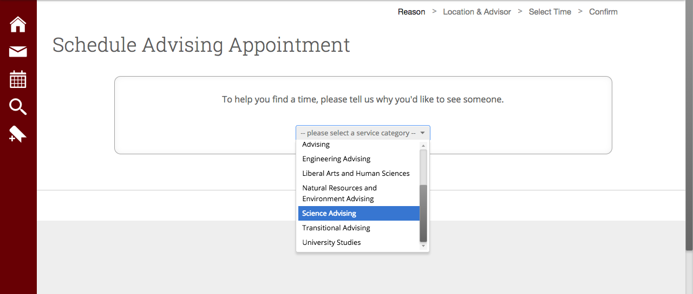

- Click on Biochemistry Advising

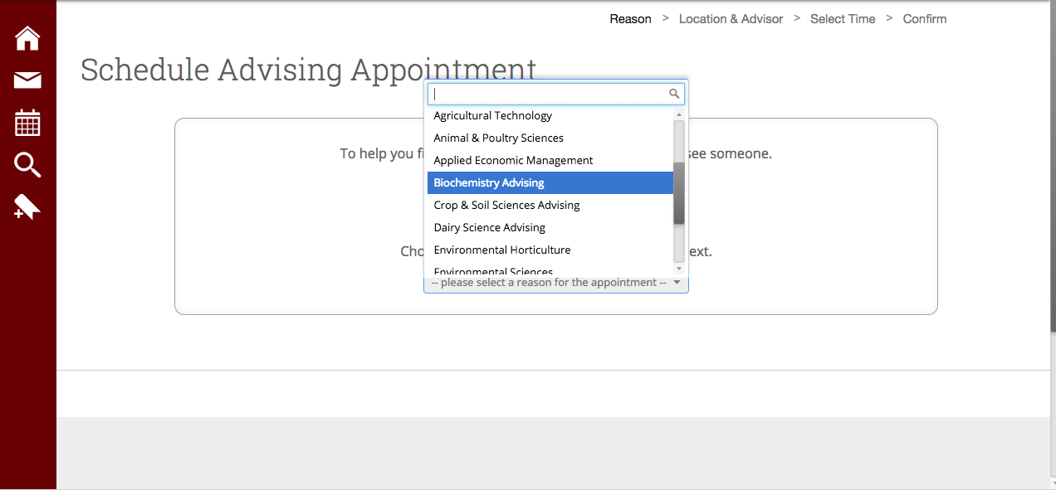

- Schedule your appointment for Engel hall with either advisor.
Molly Wilson’s typical hours: MWF 8am-1230pm & TR 1230pm-5pm
David Lally’s typical hours: MWF 1230pm-5pm

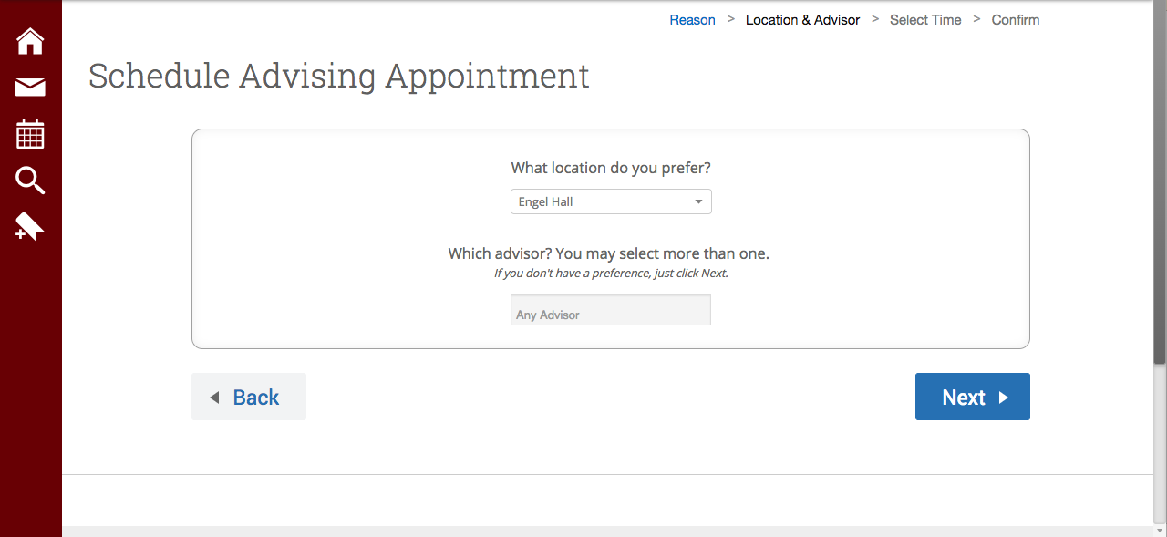

- Select a day and time that fits in your schedule for your appointment

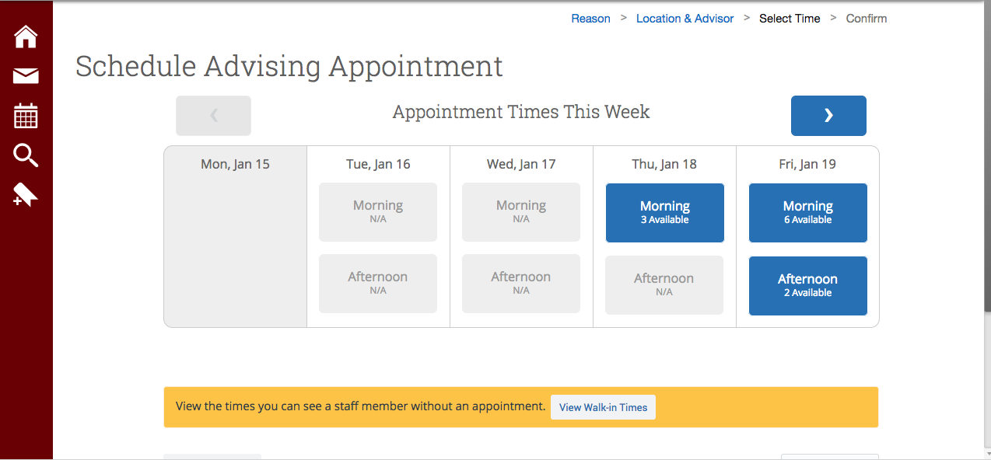

Confirm your appointment and add any comments/questions you have that your advisor can help with prior to your arrival. Add your appointment to your personal calendar and be sure to arrive on time.

